SGP – Student Growth Percentile

When using SGP with MSTEP data, the following values are the default Calculator Settings:

Weighting per year:
- 3 YEARS OF DATA: As shown below, when a teacher/building/district has three years of data, the first year is worth 20% of the final weighted average, the second year 30% and the most recent year is worth 50% of the weighted average.
- 2 YEARS OF DATA: With two years of data, the first year is worth 40% of the final weighted average and the most recent year is worth 60% of the weighted average.
- 1 YEAR OF DATA: With one year of data, that year is worth 100%.

These weights are in line with Michigan Department of Education recommendations and reflect a growth mindset with the most recent year having the greatest weight. Districts can change these settings to reflect their district goals and beliefs. (see pg __ for steps)

Cut Scores reflect the final weighted average student growth percentile:
- 60+ Highly Effective
- 40 - < 60 Effective
- 20 - < 40 Minimally Effective
- 0 - < 20 Ineffective

The Michigan Department of Education recommends that districts do not lower the cut scores. However, if the district is one which has experienced high growth and they wish to provide a more challenging set of cut scores, they are free to do so.

The Minimum Student Count is set at 20 students but may be changed by the district. To change any of these numbers, simply highlight the number you wish to change and type the number your district wants to use instead. The tool will automatically recalculate the new settings.

To return to Default Settings, simply click “Reset to Default.”

Where does the data come from?

Use Case Practice – District/Building Attribution

- Set the weighted values for the three years if it’s not 50, 30, 20 and for the two-year weights if it’s not 60, 40.

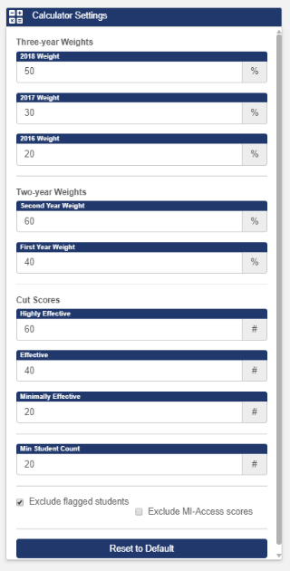
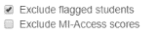
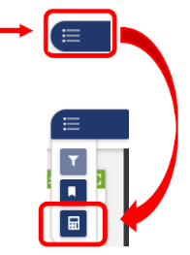
After clicking the slider at top right, the Calculator is the option shown on the bottom

Clicking on the Calculator will bring up all the Calculator settings.

To change any of these numbers, simply highlight the number you wish to change and type the number your district wants to use instead. The tool will automatically recalculate the new settings.

Please note weighted values will RESET if you refreshed, leave the SGP calculator, or log off the system.

- View the district yearly average SGPs and final SGP score based on the calculator settings your district has chosen.
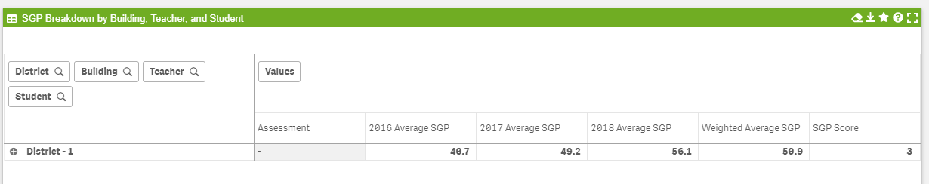

- Expand the district label to view individual building-level scores by clicking on the + sign to the left of the district title.
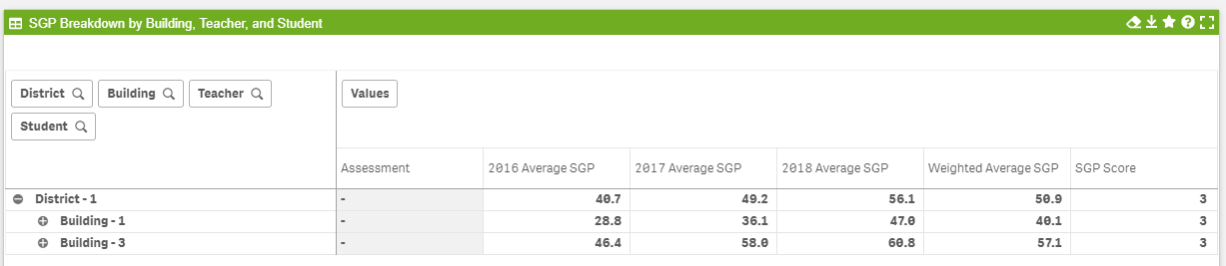

Use Case Practice – Individual Attribution

- Set the weighted values for the three years if it’s not 50, 30, 20 and for the two-year weights if it’s not 60, 40.

After clicking the slider at top right, the Calculator is the option shown on the bottom

Clicking on the Calculator will bring up all the Calculator settings.

To change any of these numbers, simply highlight the number you wish to change and type the number your district wants to use instead. The tool will automatically recalculate the new settings.

Please note weighted values will RESET if you refreshed, leave the SGP calculator, or log off the system.

- Make sure to filter by Content Area if you are not using ELA, Math, Science and Social Studies.

The Filter Panel is accessed by clicking on the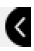 shown centered at the right side of the screen. As shown below, potential filters include Subject, Cohort, Ethnicity, Grade or Gender.

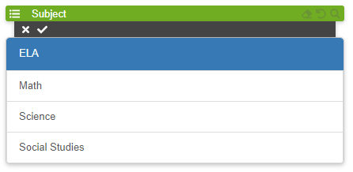
To select any filter, click on it. When you do so, the selected item will be highlighted. Then click the ✓ at the top of that specific filter category. For example, to select Female, click on “ELA,” then click the ✓ at the top left just below “Subject.” If you decide not to use ELA as a filter, click the x.

- Filter to the school, if applicable.

The tab colors are green by default with the user’s initial level of granularity shown in purple. When a user clicks on the individual tab, the color changes to purple. A user can also click on any tab to the right of their user level. Clicking on the tab will influence the options on the tabs to the right and will change the chart displays within the modules.
For example, when the District tab is selected and shows purple, the chart displays will show data by building (next tab to the right). If Building tab is selected and shows purple, the chart displays will show data by teacher (next tab to the right), and so on. Clicking on the drop-down arrow to the right of Building will show all the buildings in the district.

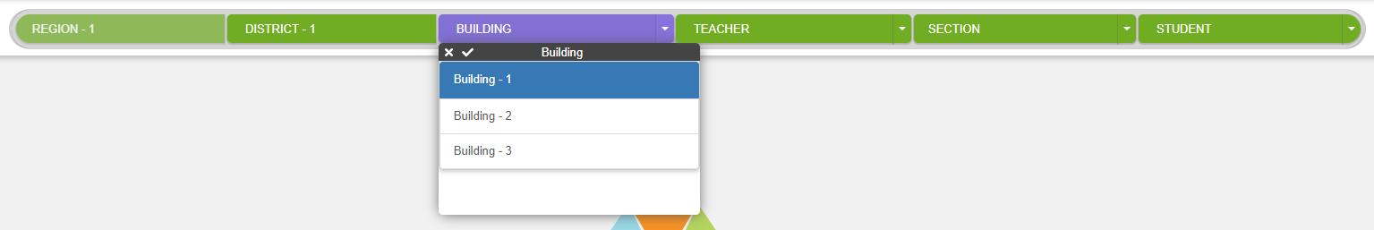

To select a Building, click on your selection and then click on the ✓. To cancel, click the x. To close the tab, click on the drop-down arrow to the right of Building again.

- Filter to the teacher.

Repeat the steps used above by clicking on the Teacher tab. Select the teacher, click the ✓, and close the list by clicking on the drop-down arrow.

- Filter to the appropriate sections for that teacher, if applicable. Course IDs are needed to filter by section.

Repeat the steps used above by clicking on the Section tab. Select the section(s), click the ✓, and close the list by clicking on the drop-down arrow. *You will need Course IDs from the SIS to filter by section.

- Exclude any students, if applicable.

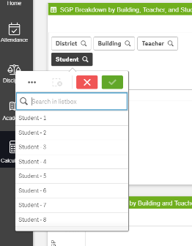
To exclude students from being included in calculations, begin by clicking on the student button in upper left corner of the chart.

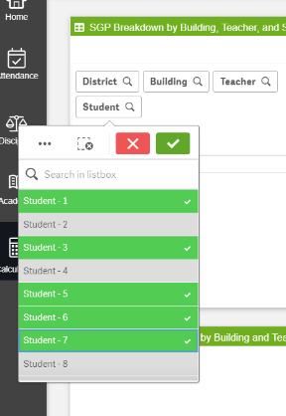

Click on the names of the students to be excluded. They will be identified in green with a checkmark. The calculator will begin to calculate data only for the students selected.

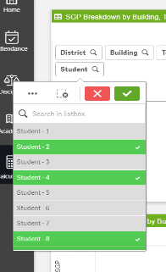
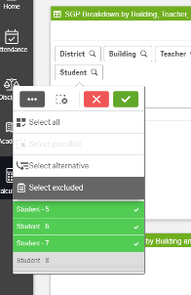
Click the 3 dots in upper left of dropdown and click on select
excluded. This will swap the students who have been selected
for those that were not, allowing the calculations to reflect the
larger group of students. Click the green checkmark to proceed
with viewing calculations.
After “select excluded”

To verify which students were excluded, scroll to the bottom of the dropdown list. Excluded students will now appear in grey.
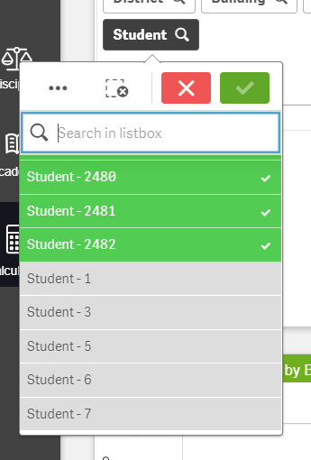

- Save the applied filters by including teacher name and school year in the name convention.

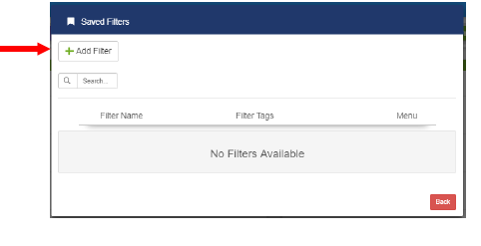
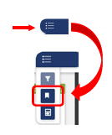
To access the Bookmark/Saved Filters, click on the slider at the top right and then click the middle icon.

To save the filters you have selected, click + Add Filter.

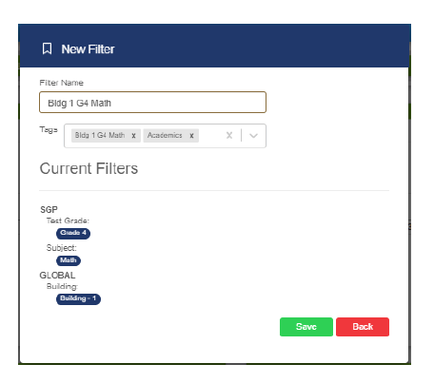

All the filters you have selected are shown on the bottom.

Type a Filter Name (for example: Bldg 1 G4 Math) and add whatever tags you desire, then click “Save.”

You will get a message that tells you “Your filter has been saved.”

Click the red “Back” button once.

The filter will now show with the Filter Name, Filter Tags and Menu of options.
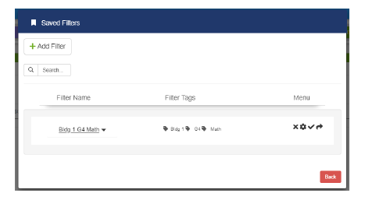
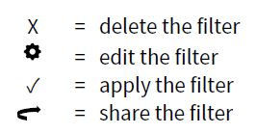

The filter may be shared with any district license holder. Clicking the red Back button once again will take you back to your original screen.

Please note this will not save any changes to the calculator settings, i.e. three-year or two-year weights. Saving the applied filters for each teacher will save time if administration needs to recall the information at a later date.

- Export teacher information to Excel.

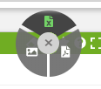
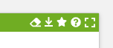
Click the download icon and then choose the green Excel icon.

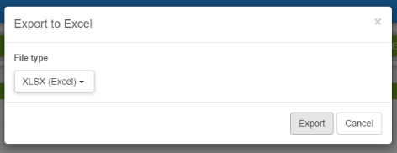
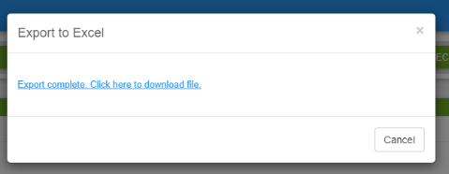
Click the export button and then the link to download the file once it is complete.

- Save the file with the teacher’s name and year in the file name.
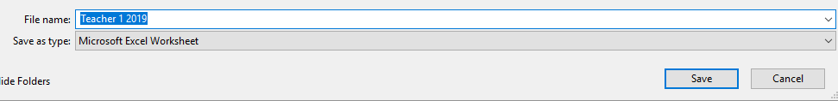

- Screenshot filters and weights to add to exported spreadsheet. Also, type excluded student list if not included in the export.

- Save.
- Repeat the above steps for the next teacher.

